Message Center Switch – 5 Button HW Interface to IPC – CGEA 1.3

Functional Description

The 3.5" and larger LCD display clusters typically use a 5 button switch located on the steering wheel. The switch has an "OK" button in the center, and 4 directional arrows.

On certain CGEA 1.1 vehicles (currently P415 and P473), this switch is hardwired to the IPC, and the button press information is read by the cluster through an A/D channel. In other applications, this switch can be hardwired to the SCCM and the button press is sent to the IPC over HSCAN. That configuration is handled in a different STSS, refer to Message Center Switch – 5 Button HSCAN Interface via SCCM.

The IPC will debounce the switches approximately 50ms. Also, the IPC will handle a stuck button condition. Once a switch is pressed for 2 minutes, the IPC will interpret as 'off' (not pressed).

Interfaces

Interface Context Diagram (I/O Block Diagram)

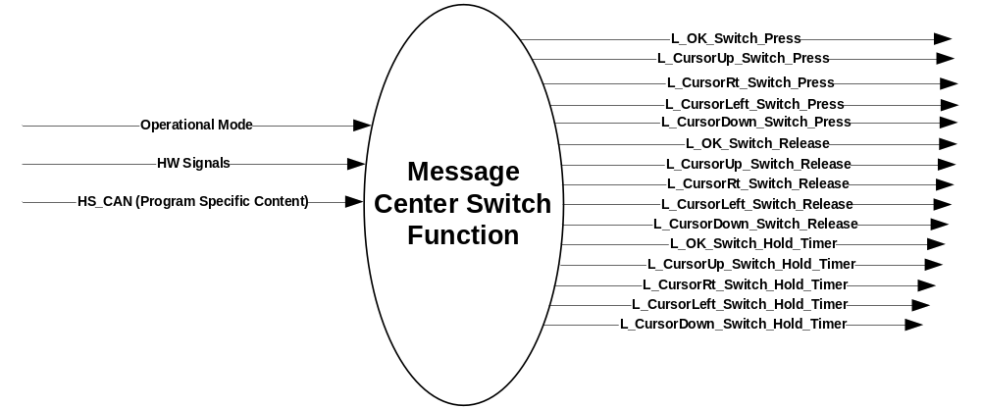

Inputs
Reference section 1.2.1 Interface diagram:

Outputs

L_OK_Switch_Press
L_CursorUp_Switch_Press
L_CursorRt_Switch_Press
L_CursorLeft_Switch_Press
L_CursorDown_Switch_Press
L_OK_Switch_Release
L_CursorUp_Switch_Release
L_CursorRt_Switch_Release
L_CursorLeft_Switch_Release
L_CursorDown_Switch_Release
L_OK_Switch_Hold_Timer
L_CursorUp_Switch_Hold_Timer
L_CursorRt_Switch_Hold_Timer
L_CursorLeft_Switch_Hold_Timer
L_CursorDown_Switch_Hold_Timer

Function/Performance

Operational Modes
Current Operating Mode | Functionality in Current Operating Mode
Sleep Mode | OFF
Limited Mode | OFF / Process Switch Input
Normal Mode | Process Switch Input
Crank Mode | Process Switch Input

Voltage Levels
Refer to Cluster Features table located in the Operational Modes and Voltage Range Strategies Section in this SPSS.

Human-Machine Interface

Visual

Graphics / Display Format – 4.2”
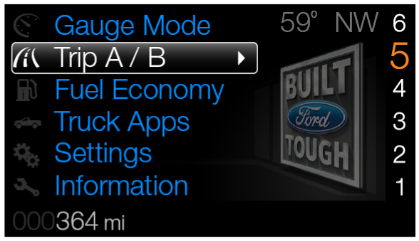

5-Buttons Format
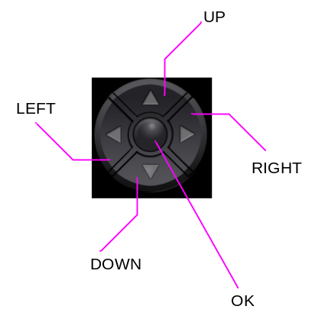

Indicator Graphics / Display Format
None

Indicator Color Coordinates
None

Indicator Characteristics
None

Audio
None

Switch Control Logic
Consumer access to message center displays shall be as specified in the Message Center – HMI Display STSS.

System Accuracy
Within 100 msec of receiving a message that results in a change of state the cluster will update the display to the proper state.

Operation: Performance and Functional

Subsystem Algorithm Flowchart / State Diagram
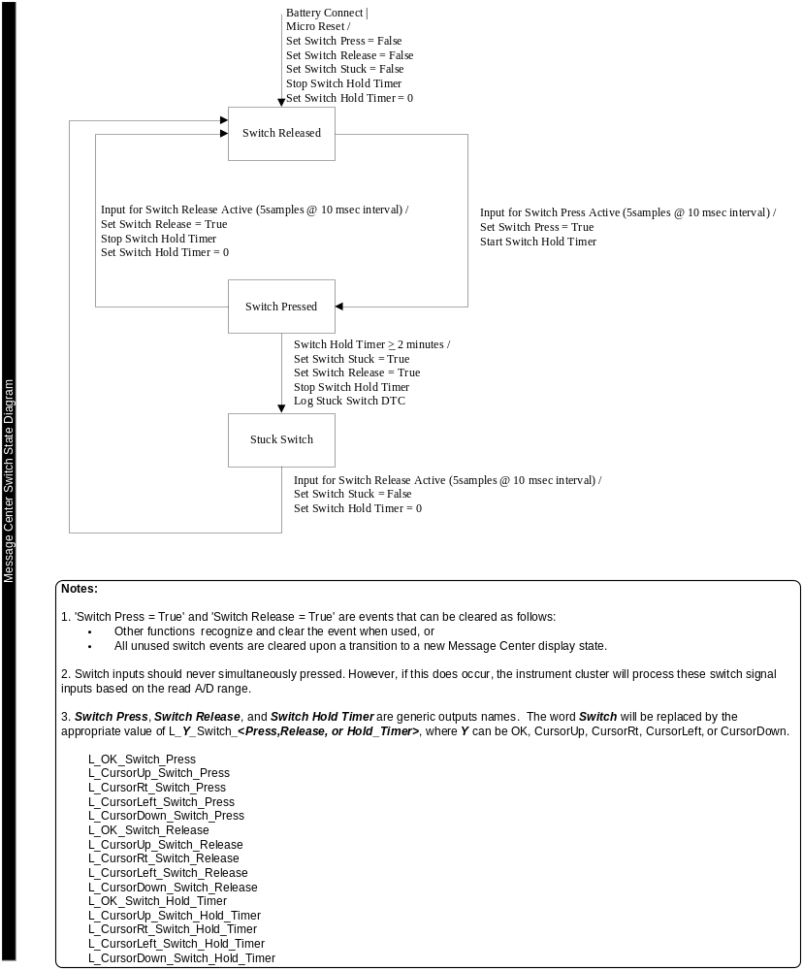

Operation Description (supports algorithm flowchart /state diagram)

The Hardware requirements will dictate the A/D range and corresponding bands for the operation of the
5-button Message Center switch:

ITEM | FUNCTION | A/D VALUE  (MIN) | A/D VALUE  (TYP) | A/D VALUE  (MAX) | COMMENTS
Message Center  5-button  (TFT ONLY) | OPEN CIRCUIT | OPEN_min | OPEN_typ | OPEN_max | Log DTC for open  ( A2D_open is within range)
Message Center  5-button  (TFT ONLY) | SHORT_CIRCUIT | SHORT _min | SHORT _typ | SHORT _max | Log DTC for short  ( A2D_short is within range)
Message Center  5-button  (TFT ONLY) | NORMAL | NRML_min | NRML_typ | NRML_max | -
Message Center  5-button  (TFT ONLY) | OK | OK_min | OK_typ | OK_max | Log DTC for stuck  (A2D_stuck is within range for for > 2 minutes)
Message Center  5-button  (TFT ONLY) | DOWN | DOWN_min | DOWN_typ | DOWN_max
Message Center  5-button  (TFT ONLY) | RIGHT | RIGHT_min | RIGHT_typ | RIGHT_max
Message Center  5-button  (TFT ONLY) | UP | UP_min | UP_typ | UP_max
Message Center  5-button  (TFT ONLY) | LEFT | LEFT_min | LEFT_typ | LEFT_max

Function Safety Classification (EMC)

Class B.

Memory Storage
Timer Definitions
 |  | Timers shall be programmable within the following range : *
Timer Name | Duration | Description | Min | Max | Resolution
Switch Hold Timer | 120 s | Any MC switch input that remains active/on for this duration will be assumed to be a "Stuck Switch" | 0 s | 255 s | 1 s

Prove-Out
No

Error Handling

Missing Message Strategy

Diagnostics

Self Test
None

Engineering Test Mode
Reference section “Dealer / Engineering Test Mode (ETM)”

Part II Performance

Supported Diagnostic Trouble Codes (DTCs)
DTC | Description | When Logged
9A8209 | Stuck Switch | Switch is pressed for more than 2 minutes.
9A8211 | Short* Circuit | Short Circuit Condition.
9A8212 | Open* Circuit | Open Circuit Condition.
* Depending on Hardware, Short or Open may not be supported.

Mod Conf (Method 2)
Block  Num | Block Description | Size (bits) | Type | Byte(s) | Bits | State: Description | "0" | "1" | Default | Comments/  Information
PACKETED BLOCKS
 | None
*Byte and bit location to be identified in Part II Specification for this cluster

Reference Specification

Revision History
SPSS Module Revision History

Revision Level | Name | Change Description | Date
1.0 | V. Patel | Initial release.  Updated for CGEA1.3 based on CGEA Message Center Switch – 5 Button HW Interface STSS v1.0  No updates needed. | 5/11/2010

